Investigating Adaptation of Contextual Contrast Edges in Lightness Computations

See contAdapt_francis\Code\Stimuli_&_Noise Maskswhitesillusion.py (“checker”/ “checker_patch”/ “checker_odd stimuli cases”) for code

Cue-based approach to lightness computation requires investigations into which image components are used to construct a lightness map. Contrast is often discussed as a likely cue for lightness computation. It has been observed that adapting the contrast edges within various simple stimuli can result in a change of perceived lightness in the image. The simplest examples of this indicate edges act as colour “dams” which constrain the lightness of a region and once the edges of this region are adapted the lightness will merge with the surrounding lightness value. Thus, in this way, contour adaptation has the ability to modulate contrast. Contrast normalization models are a cue-based approach to lightness computation which considers the context in the local surround of a test patch in computing the test patch’s lightness. Therefore, we should be able to test these models ability to quantify local contrast edge modulations under the influence of adaptation. The usual approach would be to modulate the surround test patch luminance values, instead we can instead approach the problem from changing the explicit contrast values themselves, that is the magnitude of the edge signals.
Simple checker-board stimuli were created as below, with two test patches (1 & 2) being equiluminant and surround ‘black’ and ‘white’ checks are equidistant above and below this central gray test patch value, respectively.

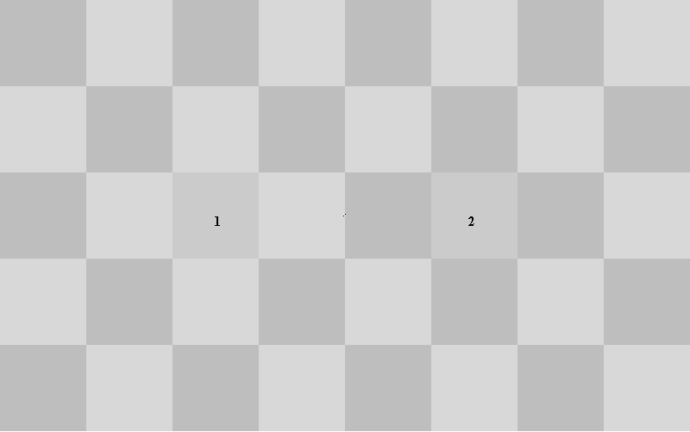
Figure 1 - Raw test stimuli
Adapting immediate surround edges of test patches causes absolute assimilation with surrounding test patches, that is 1 changes to white and 2 changes to black (Illustration 2) (Note: Fixation point is quite small in these Illustrations, but just make the figure larger).
If we instead modulated non-immediate surround contrast edges, the test patches appear to assimilated with the pattern in a more obvious way, that is 1 appears darker and 2 appears lighter. However this affect is also observed when simply fixating on the fixation marker on the raw test stimuli (Figure 1), so cannot be entirely attributed to context contrast modulation.

Figure 2 - Immediate contrast test patch edge adaptation
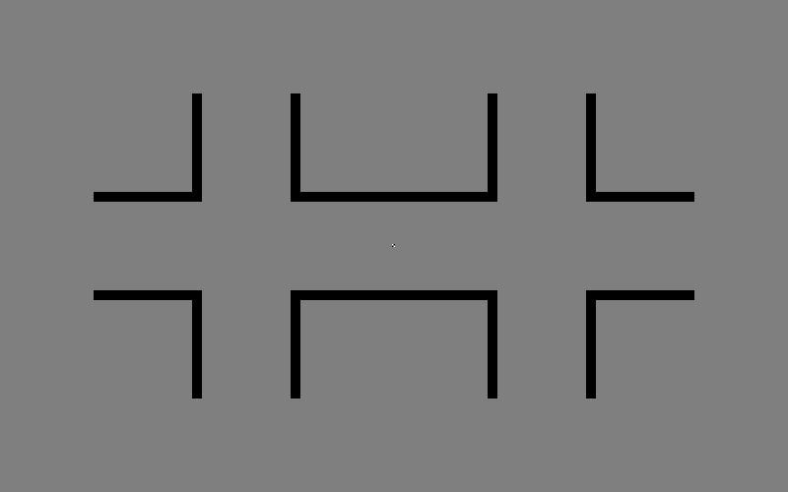
Figure 3 - Surround contrast test patch edge adaptation

The following stimuli adapts the surrounding checkers as seen below.
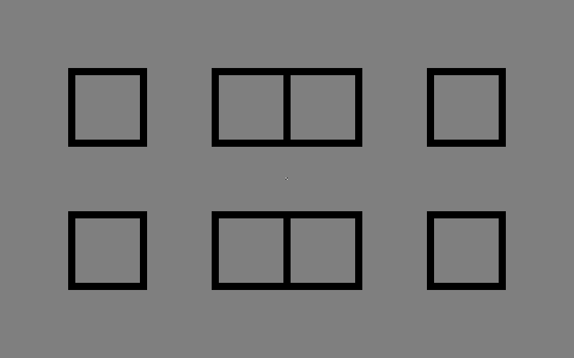
With all of these stimuli, the relatively short period under which the effect occur make it difficult to report on any lightness changes observed, as there is no way to “freeze-frame” the perceptual experience. So making this a viable experimental method in exploring contextual contrast changes is debatable. Furthermore, as previously mentioned, fixation is rather an unnatural viewing condition and separating fixation effects from adaptation effects is difficult. Finally, lightness changes under adaptation only work under low contrast images, it would simply not occur under high contrast stimuli and therefore could be the result of the brain over-compensating for the ambiguous stimuli rather than revealing underlying processes in lightness computation.

Open questions & Development:
- Should we define contrast as explicitly edge magnitude between two regions of different colour (as extracted by a Gaussian filter), as the difference between the luminance values of the two regions or could there be some other definition? Which contrast type does the brain use?
- What influence does the repeatability of the checkerboard have on the assimilation? Would a more stable stimuli be created by reducing the surround size?
- Assuming adaptation could be used for reliable context modulation, how would we incorporate this into a normalization scheme?

References
Linking luminance and lightness by global contrast normalization - Katharina Zeiner; Marianne Maertens
http://jov.arvojournals.org/article.aspx?articleid=2564712

